- MESI State Transitions
Describe what happens in the MESI protocol (bus traffic, state changes) if a processor experiences
1.1 a local read miss, while no other processor has the requested value cached
Processor requests data from memory, state of line is exclusive.

1.2 a local read miss, while another cache holds a copy in exclusive state
Processor requests data from memory, other processor sees the request, puts his copy on the bus and thememory request is cancelled. Both processors set the state of the cached line to shared.

1.3 a local read miss, while another cache has a copy in modified state
Processor requests data from memory, other processor sees the request, puts his modified copy on the busand the memory request is cancelled. The modified value is written back to memory. Both processors set the state of the cached line to shared.

1.4 a local write hit, while the cacheline is in modified state
locally cached value is updated, state remains modified.

1.5 a local write hit, while the cacheline is in exclusive state
locally cached value is updated and its state changes from exclusive to modified.

1.6 a local write hit, while the cacheline is in shared state in several caches
Modyfying processor broadcasts and invalidate message on the bus, other processors set their state to invalid,
local value is updated and its state is set to modified.

- Cache coherence
Action | P0 | P1 | P2 | P3 | Latency
R0 (00000000) | E | I | I | I | 8
R1 (00000010) | S | S | I | I | 8
R2 (00000011) | S | S | S | I | 8
W3(00000010) = 1 | I | I | I | M | 2+8
W3(00000101) = 2 | I | I | I | M | 1
R0 (00000100) | S | I | I | S | 8+8
W0(00000101) = 3 | M | I | I | I | 2+1
The machine described above uses the MESI protocol to maintain cache coherence. In the following Rp(a) means that processor p reads one byte from the address a. Wp(a) = v means processor p writes v to the memory location a. Addresses are represented in binary. Initially all cache lines are invalid and all memory locations contain 0. Show the transitions of cache lines in the table below.

Assume a cache hit takes one cycle (both for read and write operations), transferring a cache line (either fetch or write back) takes 8 cycles, and a request to use a cache line exclusively (transition I - M) resp. a request to update to exclusive use (transition S - M) takes 2 cycles. What is the penalty of this code sequence over the best alternative execution sequence that you can think of?
In total this takes 54 cycles.
If we reorder this sequence into R 0 (00000000), R 0 (00000100), W 0 (00000101) = 3, R 1 (00000010), R 2 (00000011),W 3 (00000100) = 1, W 3 (00000101) = 2 it takes only 45 cycles.

- False sharing
The listed code is executed on a bus-based multiprocessor with 2 processors that uses the MESI protocol to maintain cache coherence. Assume the array x takes up an entire cacheline of 64 Byte.
intx [ 1 6 ] ;
int tid ;
#pragma omp parallel private (tid ) shared (x)
{
tid = omp_get_thread_num( ) ;
for (int i = 0; i <8; i ++) {
if (tid == 0) x[i∗2+ tid ] = 1 ;
if (tid == 1) x[i∗2+ tid ] = 2 ;
}
}
Assume that memory accesses of the above program are interleaved in a round-robin fashion. Assuming the same access penalties as in the previous exercise what is the total memory access latency encountered by the the above program? How could one improve the situation?
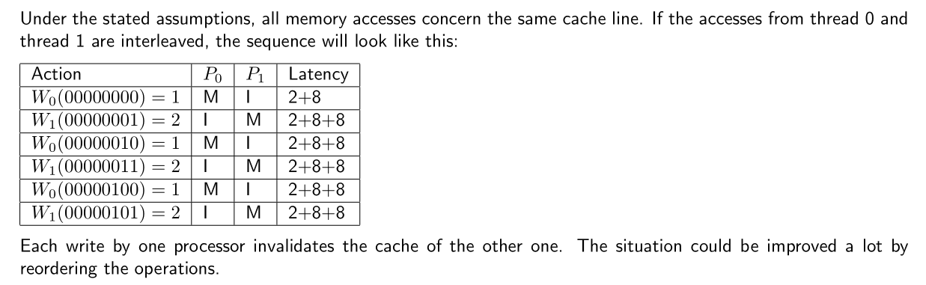

4. Directory-based Cache Coherence Update Protocols
Ben wants to convert the directory-based invalidate cache coherence protocol from the handout into an update protocol. He proposes the following scheme.

Caches are write-through, not write allocate. When a processor wants to write to a memory location, it sends a WriteReq to the memory, along with the data word that it wants written. The memory processor updates the memory, and sends an UpdateReq with the new data to each of the sites caching the block, unless that site is the processor performing the store, in which case it sends a WriteRep containing the new data.

If the processor performing the store is caching the block being written, it must wait for the reply from the home site to arrive before storing the new value into its cache. If the processor performing the store is not caching the block being written, it can proceed after issuing the WriteReq.

Ben wants his protocol to perform well, and so he also proposes to implement silent drops. When a cache line needs to be evicted, it is silently evicted and the memory processor is not notified of this event.

Note that WriteReq and UpdateReq contain data at the word-granularity, and not at the block-granularity. Also note that in the proposed scheme, memory will always have the most up-to-date data and the state C-exclusive is no longer used.

As in the lecture, the interconnection network guarantees that message-passing is reliable, and free from deadlock, livelock, and starvation. Message-passing is FIFO. Each home site keeps a FIFO queue of incoming requests, and processes these in the order received.

4.1 Alyssa claims that Ben’s protocol does not preserve sequential consistency because it allows two processors to observe stores in different orders. Describe a scenario in which this problem can occur.

Consider blocks X and Y, whose home sites are A and B, respectively: 1. A receives a WriteReq for X, and B receives a WriteReq for Y 2. C and D are both caching X and Y. So both A and B send UpdateReq to C and D. 3. C receives first the UpdateReq for X, then the UpdateReq for Y 4. D receives first the UpdateReq for Y, then the UpdateReq for X

C and D can receive the UpdateReq in different orders because they are arriving from different home sites, and FIFO message passing only provides guarantees for messages with the same source and destination

4.2 Noting that many commercial systems do not guarantee sequential consistency, Ben decides to implement his protocol anyway. Fill in the following state transition tables (Table 4-1 and Table P4-2) for the proposed scheme. (Note: the tables do not contain all the transitions for the protocol).

No. | Current State | Event Received |  | Next State | Action
1 | C-nothing | Load |  | C-transient | ShReq(id, Home, a)
2 | C-nothing | Store |  | C-transient | WriteReq(id, Home,a)
3 | C-nothing | UpdateReq |  | C-nothing | None
4 | C-shared | Load |  | C-shared | processor reads cache
5 | C-shared | Store |  | C-transient | WriteReq(id, Home,a)
6 | C-shared | UpdateReq |  | C-shared | data -> cache
7 | C-shared | (Silent drop) |  | C-nothing | Nothing
8 | C-transient | ShRep |  | C-shared | data → cache, processor reads cache
9 | C-transient | WriteRep |  | C-shared | data -> cache, Store retires
10 | C-transient | UpdateReq |  | C-transient | data -> cache
 |  |  | Table P4-1: Cache State Transitions
No. | Current State |  | Message | Next State | 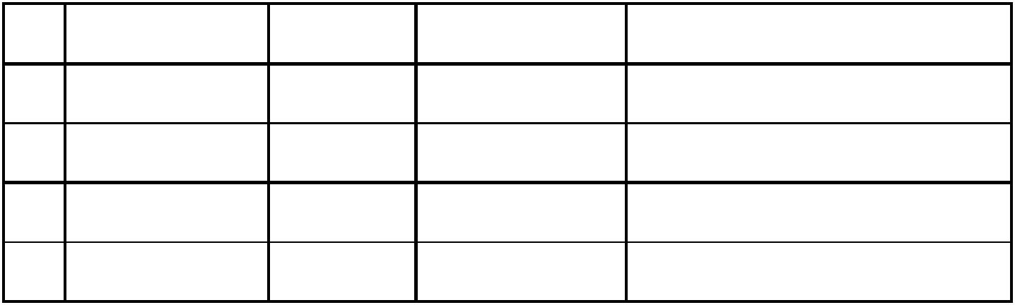  Action
 |  |  | Received
1 | R(dir) & id ∉ dir |  | ShReq | R(dir + {id}) | ShRep(Home, id, a)
2 | R(dir) & id ∉ dir |  | WriteReq | R(dir + {id}) | data → memory, if(i==id) Write Rep -> id, else UpdateReq -> i
3 | R(dir) & id ∈ dir |  | ShReq | R(dir) | ShRep(Home, id, a)
4 | R(dir) & id ∈ dir |  | WriteReq | R(dir) | data → memory, if(i==id) Write Rep -> id, else UpdateReq -> i
 |  |  | Table P4-2: Home Directory State Transitions (N = “is not in”)

4.3 After running a system with this protocol for a long time, Ben finds that the network is flooded with UpdateReqs. Alyssa says this is a bug in his protocol. What is the problem and how can you fix it?
Because caches do not notify the home site when a line gets replaced, the set S for a memory block will only increase. Eventually, every site that has ever loaded a particular block will be in the set S for that block, resulting in numerous UpdateReq on the network, even though many of the recipients of the update have already replaced that cache line. The solution is to notify the home site when a cache line is replaced, and have the home site remove a site from S when such a notification is received.

4.4 FIFO message passing is a necessary assumption for the correctness of the protocol. If the network were non-FIFO, it becomes possible for a processor to never see the result of another processor’s store. Describe a scenario in which this problem can occur.
Consider a site A: 1. Site A sends ShReq for block X to X’s home site. 2. X’s home site receives ShReq and issues a ShRep. 3. Site B sends a WriteReq for block X to X’s home site. 4. X’s home receives WriteReq, and issues an UpdateReq to A 5. The ShReq and UpdateReq are re-ordered in the network 6. The UpdateReq arrives at A. Since A is waiting for ShRep, it is in C-transient. It updates its cache with the UpdateReq data, but remains in C-transient. 7. The ShRep arrives at A. The cache writes the stale data into its cache, and reads the result.

Although A received the UpdateReq, it will never see the result of B’s store unless the cache linegets replaced, and is re-loaded.

5. Sequential Consistency
For this problem we will be using the following sequences of instructions. These are small programs, each executed on a different processor, each with its own cache and register set. In the following R is a register and X is a memory location. Each instruction has been named (e.g., B3) to make it easy to write answers.

Assume data in location X is initially 0.
Processor A | 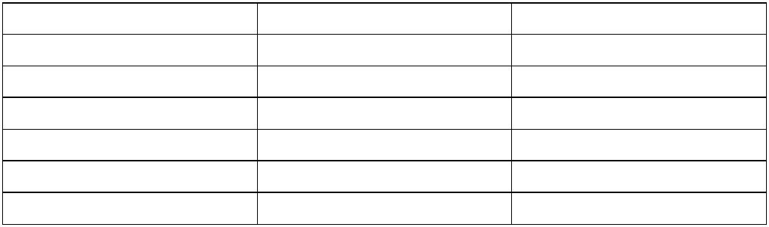  Processor B | Processor C
A1: ST X, 1 | B1: R := LD X | C1: ST X, 6
A2: R := LD X | B2: R := ADD R, 1 | C2: R := LD X
A3: R := ADD R, R | B3: ST X, R | C3: R := ADD R, R
A4: ST X, R | B4: R:= LD X | C4: ST X, R
 | B5: R := ADD R, R
 | B6: ST X, R

For each of the questions below, please circle the answer and provide a short explanation assuming the program is executing under the SC model. No points will be given for just circling an answer!

5.1 Can X hold value of 4 after all three threads have completed? Please explain briefly.

Yes / No

Yes, C1, B1-B6, A1-A4, C2-C4

5.2 Can X hold value of 5 after all three threads have completed?

Yes / No

No, all results must be even.

5.3 Can X hold value of 6 after all three threads have completed?

Yes / No

Yes, All of C, All of A, All of B

5.4 For this particular program, can a processor that reorders instructions but follows local dependencies produce an answer that cannot be produced under the SC model?

Yes / No

No, All stores/loads must be done in order because they’re to the same address, so no new results are possible.

6. Cache coherence: MESI
Assume you are designing a MESI snoopy bus cache coherence protocol for write-back private caches in a multi-core processor. Each private cache is connected to its own processor core as well as a common bus that is shared among other private caches.
There are 4 input commands a private cache may get for a cacheline. Assume that bus commands and core commands will not arrive at the same time:
- CoreRd: Read request from the cache´s core
- CoreWr: Write request from the cache´s core
- BusGet: Read request from the bus
- BusGetI: Read and Invalidate request from the bus (invalidates shared data in the cache that receives the request)
There are 4 actions a cache can take while transferring to another state:
- Flush: Write back the cacheline to lower-level cache
- BusGet: Issue a BusGet request to the bus
- BusGetI: Issue a BusGetI request to the bus
- None: Take no action
There is also an “is shared (S)” signal on the bus. S is asserted upon a BusGet request when at least one of the private caches shares a copy of the data (BusGet (S)). Otherwise S is deasserted (BusGet (not S)).
Assume upon a BusGet or BusGetI request, the inclusive lower-level cache will eventually supply the data and there is no private cache to private cache transfers.
On the next page, Rachata drew a MESI state diagram. There are 4 mistakes in his diagram. Please show the mistakes and correct them. You may want to practice on the scratch paper first before finalizing your answer. If you made a mess, clearly write down the mistakes and the changes below.

